Insert your name, centre number and candidate number into the header above.
Save this evidence document as evidence_ followed by your centre number_ candidate number. For example: evidence_ zz999_9999.doc
Screenshots or program listings must be copied into appropriate cells in the following tables.
Examiners must be able to read the contents including any screenshots without the use of a magnifying glass. Answers that are not readable or missing will not be awarded any marks.
Save this evidence document at regular intervals, for example, every 10 minutes.
Question 1
Part 1(a)(i)
{Copy and paste program code listing for question 1(a)(i) here}

class EventItem:
def __init__(self,en,t,d):
self.__EventName=en # PRIVATE EventName: STRING
self.__Type=t # PRIVATE Type: STRING
self.__Difficulty=d # PRIVATE Difficulty: INTEGER

Part 1(a)(ii)
{Copy and paste program code listing for question 1(a)(ii) here}

def GetName(self): return self.__EventName
def GetEventType(self): return self.__Type
def GetDifficulty(self): return self.__Difficulty

Part 1(b)(i)
{Copy and paste program code listing for question 1(b)(i) here}

#main
Group=[] # DECLARE Group: ARRAY[0:4] OF EventItem

Part 1(b)(ii)
{Copy and paste program code listing for question 1(b)(ii) here}

Group.append(EventItem("Bridge","jump",3))
Group.append(EventItem("Water wade","swim",4))
Group.append(EventItem("100 mile run","run",5))
Group.append(EventItem("Gridlock","drive",2))
Group.append(EventItem("Wall on wall","jump",4))

Part 1(c)
{Copy and paste program code listing for question 1(c) here}

class Character:
def __init__(self,cn,j,s,r,d):
self.__CharacterName=cn # PRIVATE CharacterName: STRING
self.__Jump=j # PRIVATE Jump: INTEGER
self.__Swim=s # PRIVATE Swim: INTEGER
self.__Run=r # PRIVATE Run: INTEGER
self.__Drive=d # PRIVATE Drive: INTEGER

def GetName(self): return self.__CharacterName

Part 1(d)
{Copy and paste program code listing for question 1(d) here}

def CalculateScore(self,Event,Difficulty):
if Event.lower()=="jump": Difference=Difficulty-self.__Jump
elif Event.lower()=="swim": Difference=Difficulty-self.__Swim
elif Event.lower()=="run": Difference=Difficulty-self.__Run
elif Event.lower()=="drive": Difference=Difficulty-self.__Drive

if Difference<=0: return 100
elif Difference==1: return 80
elif Difference==2: return 60
elif Difference==3: return 40
elif Difference==4: return 20

Part 1(e)(i)
{Copy and paste program code listing for question 1(e)(i) here}

CTarz=Character("Tarz",5,3,5,1)
CGeni=Character("Geni",2,2,3,4)

Part 1(e)(ii)
{Copy and paste program code listing for question 1(e)(ii) here}

MarkTarz=0
MarkGeni=0
for i in range(5):
if CTarz.CalculateScore(Group[i].GetEventType(),Group[i].GetDifficulty())>CGeni.CalculateScore(Group[i].GetEventType(),Group[i].GetDifficulty()):
print(f"{CTarz.GetName()} wins the event {Group[i].GetName()}")
MarkTarz+=1
elif CTarz.CalculateScore(Group[i].GetEventType(),Group[i].GetDifficulty())<CGeni.CalculateScore(Group[i].GetEventType(),Group[i].GetDifficulty()):
print(f"{CGeni.GetName()} wins the event {Group[i].GetName()}")
MarkGeni+=1
else:
print(f"The event {Group[i].GetName()} is a draw")

if MarkTarz>MarkGeni:
print(f"{CTarz.GetName()} wins, he has {MarkTarz} points")
elif MarkTarz<MarkGeni:
print(f"{CGeni.GetName()} wins, he has {MarkGeni} points")
else:
print("The group is a drew")

Part 1(e)(iii)
{Copy and paste screenshot for question 1(e)(iii) here}

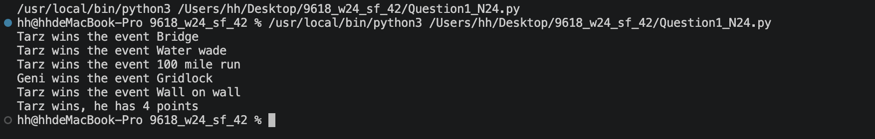

Question 2
Part 2(a)
{Copy and paste program code listing for question 2(a) here}

class Queue:
def __init__(self):
self.QueueArray=[] # DECLARE QueueArray: ARRAY[0:99] OF INTEGER
self.HeadPointer=-1 # DECLARE HeadPointer: INTEGER
self.TailPointer=0 # DECLARE TailPointer: INTEGER

Part 2(b)
{Copy and paste program code listing for question 2(b) here}

#main
TheQueue=Queue()
TheQueue.HeadPointer=-1
TheQueue.TailPointer=0
for i in range(100):
TheQueue.QueueArray.append(-1)

Part 2(c)
{Copy and paste program code listing for question 2(c) here}

def Enqueue(AQueue,TheData):
if AQueue.HeadPointer==-1:
AQueue.QueueArray[AQueue.TailPointer]=TheData
AQueue.HeadPointer=0
AQueue.TailPointer+=1
return 1
elif AQueue.TailPointer>99:
return -1
else:
AQueue.QueueArray[AQueue.TailPointer]=TheData
AQueue.TailPointer+=1
return 1

Part 2(d)
{Copy and paste program code listing for question 2(d) here}

def ReturnAllData():
global TheQueue
ResultStr=""
for i in range(TheQueue.HeadPointer,TheQueue.TailPointer):
ResultStr+=(str(TheQueue.QueueArray[i])+" ")

return ResultStr[0:len(ResultStr)-1]

Part 2(e)(i)
{Copy and paste program code listing for question 2(e)(i) here}

for i in range(10):
Valid=False
while not Valid:
Num=int(input("Input a non-negative integer(An integer that is no less than 0). "))
if Num>=0:
Valid=True
if Enqueue(TheQueue,Num)==-1:
print("Queue full")
else:
print("Sucessfully added")
else:
print("The number input is invalid")

print(ReturnAllData())

Part 2(e)(ii)
{Copy and paste screenshot for question 2(e)(ii) here}

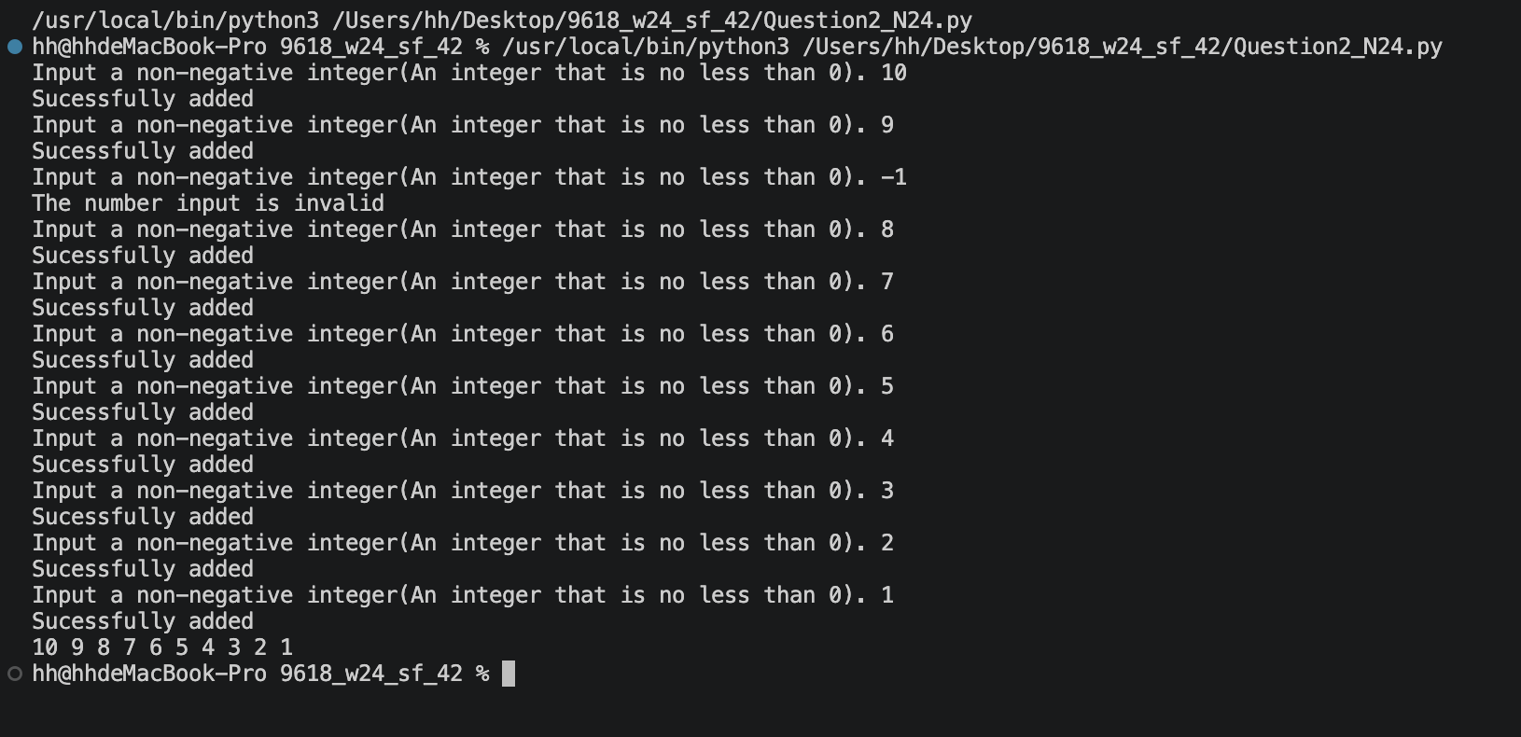

Part 2(f)
{Copy and paste program code listing for question 2(f) here}

def Dequeue():
global TheQueue
if TheQueue.HeadPointer==-1 or TheQueue.HeadPointer==TheQueue.TailPointer:
return -1
Result=TheQueue.QueueArray[TheQueue.HeadPointer]
TheQueue.HeadPointer+=1
return Result

Part 2(g)(i)
{Copy and paste program code listing for question 2(g)(i) here}

print("")
for j in range(2):
Num=Dequeue()
if Num>-1: print(Num)
else: print("Queue empty")
print("")
print(ReturnAllData())

Part 2(g)(ii)
{Copy and paste screenshot for question 2(g)(ii) here}

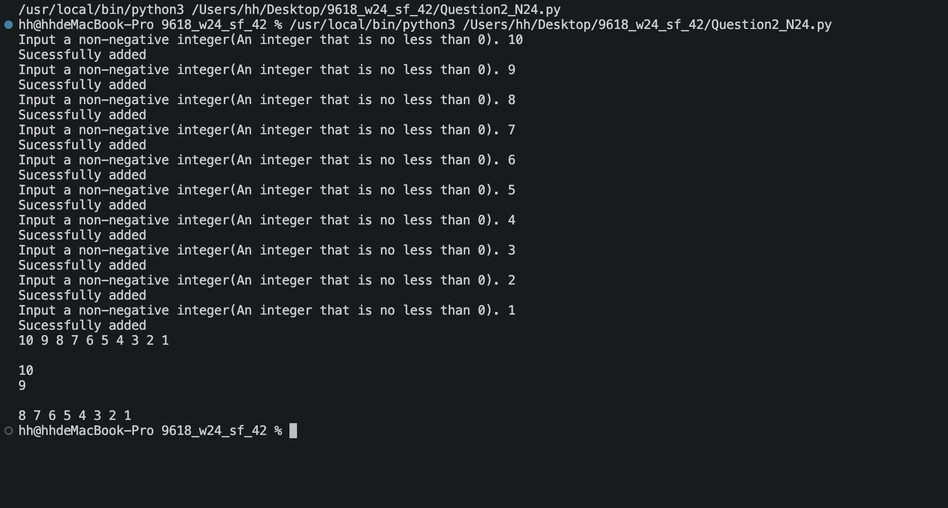

Question 3
Part 3(a)
{Copy and paste program code listing for question 3(a) here}

#main
HighScores=[["" for j in range(3)] for i in range(7)] #DECLARE HighScores: ARRAY[0:6, 0:3] OF STRING

Part 3(b)
{Copy and paste program code listing for question 3(b) here}

def ReadData():
try:
fr=open("HighScoreTable.txt",'r')

Array=[]
x=fr.readline().strip()
while x != "":
Id=x
Level=fr.readline().strip()
Score=fr.readline().strip()
x=fr.readline().strip()
Array.append([Id,Level,Score])

fr.close()
return Array
except IOError:
print("File not found.")

Part 3(c)
{Copy and paste program code listing for question 3(c) here}

def OutputHighScores(Array2D):
for info in Array2D:
print(f"{info[0]} reached level {info[1]} with a score of {info[2]}")

Part 3(d)
{Copy and paste program code listing for question 3(d) here}

def SortScores(Array2D):
Terminal=len(Array2D)-1
Swapped=True
while Swapped and Terminal>0:
Swapped=False
for i in range(Terminal):
if (int(Array2D[i][1])<int(Array2D[i+1][1])) or (int(Array2D[i][1])==int(Array2D[i+1][1]) and int(Array2D[i][1])<int(Array2D[i+1][2])):
Temp1=Array2D[i][0]
Temp2=Array2D[i][1]
Temp3=Array2D[i][2]
Array2D[i][0]=Array2D[i+1][0]
Array2D[i][1]=Array2D[i+1][1]
Array2D[i][2]=Array2D[i+1][2]
Array2D[i+1][0]=Temp1
Array2D[i+1][1]=Temp2
Array2D[i+1][2]=Temp3
Swapped=True
Terminal-=1
SortedArray=Array2D
return SortedArray

Part 3(e)(i)
{Copy and paste program code listing for question 3(e)(i) here}

HighScores=ReadData()
print("Before")
OutputHighScores(HighScores)
HighScores=SortScores(HighScores)
print("After")
OutputHighScores(HighScores)

Part 3(e)(ii)
{Copy and paste screenshot for question 3(e)(ii) here}

